**Real-Time Sound Classification using ESP32-S3**

**Introduction**

In the age of smart environments and IoT-based solutions, sound classification offers a vital component for real-time event detection and automation. This project presents the development and deployment of a real-time audio classification system using the ESP32-S3 microcontroller. The system captures audio through a PDM (Pulse-Density Modulation) microphone, extracts relevant features, performs sound classification using a lightweight deep learning model, and displays results on a web-based dashboard hosted directly on the ESP32-S3.

**Objectives**

* Develop a lightweight, real-time sound classification system using ESP32-S3.
* Classify sounds into six predefined categories.
* Deploy a model optimized for low-resource environments.
* Build a local web dashboard to display classification results with timestamps.

**Use Cases**

**Smart Home Automation**

Detecting events such as alarms or doorbells to automate responses like sending alerts or turning on lights.

**Surveillance**

Monitor for unusual sounds like breaking glass, dog barking, or raised voices, indicating potential security issues.

**Elderly Care Monitoring**

Detect crying or distress sounds from the elderly or babies for timely alerts to caregivers.

**Project Breakdown**

1. **Sensor and Hardware Setup**
2. **Data Collection and Preprocessing**
3. **Feature Extraction**
4. **Model Training and Evaluation**
5. **Model Optimization for ESP32-S3**
6. **Model Deployment**
7. **Web Dashboard Development**
8. **Real-Time Testing and Validation**

**Hardware & Sensor Setup**

**Components Used**

* **ESP32-S3**: A powerful, energy-efficient microcontroller with Wi-Fi support.

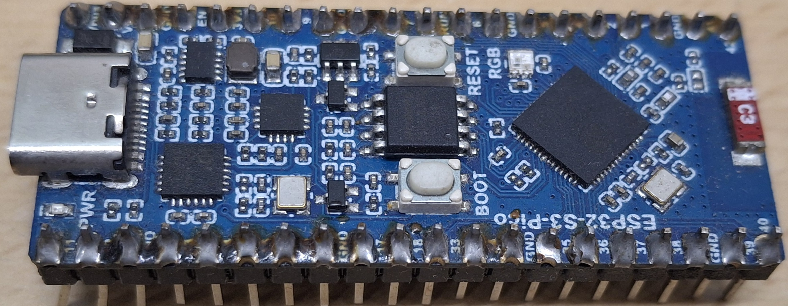

* **PDM Microphone**: Used to capture high-quality audio signals.

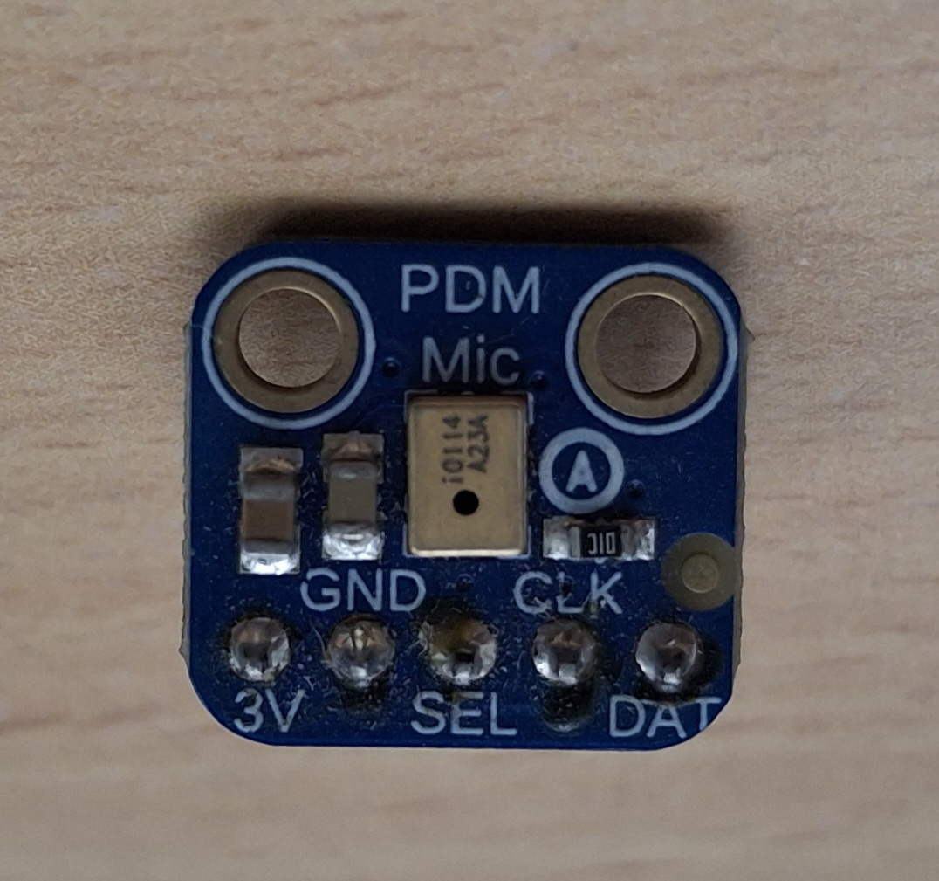

* **SD Card** : For storing recorded audio files during the data collection phase.

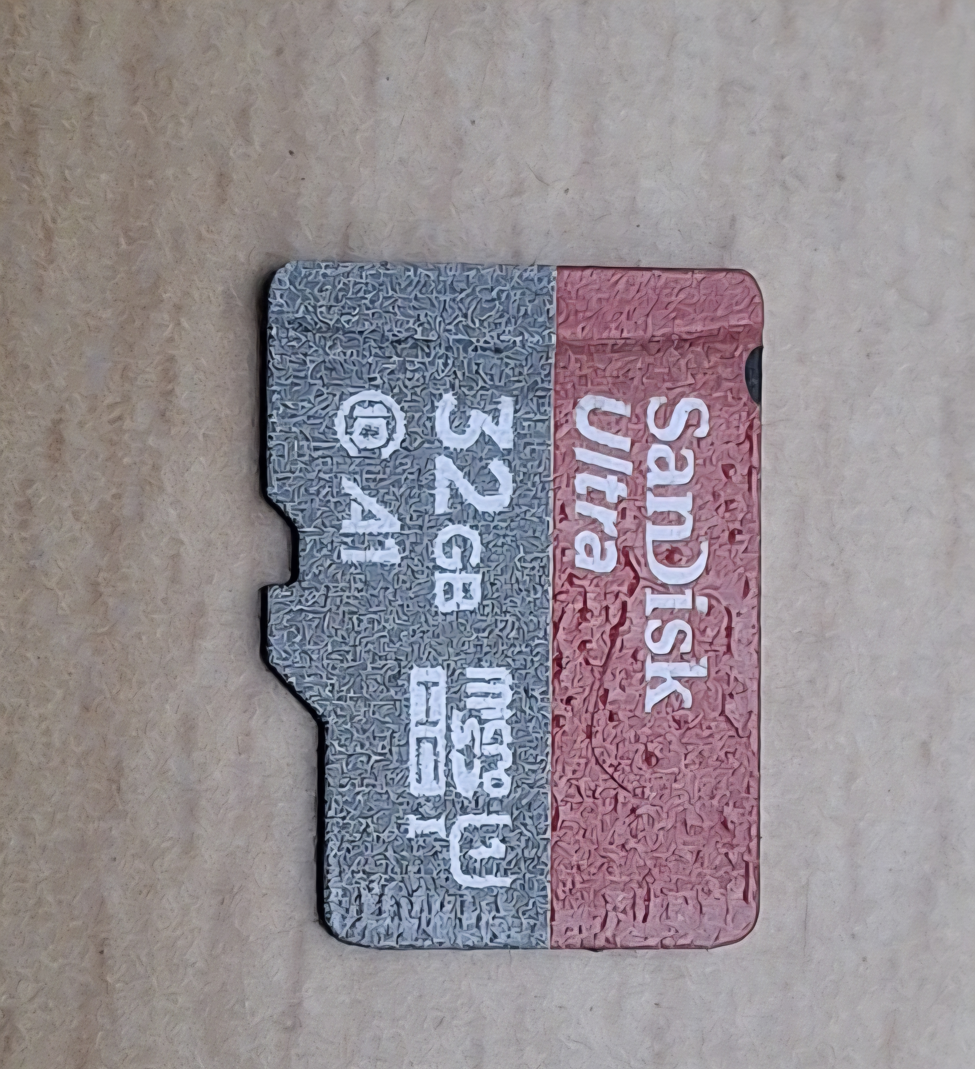

The hardware setup involves connecting the microphone and SD card module to the ESP32-S3 via I2S and SPI interfaces respectively.

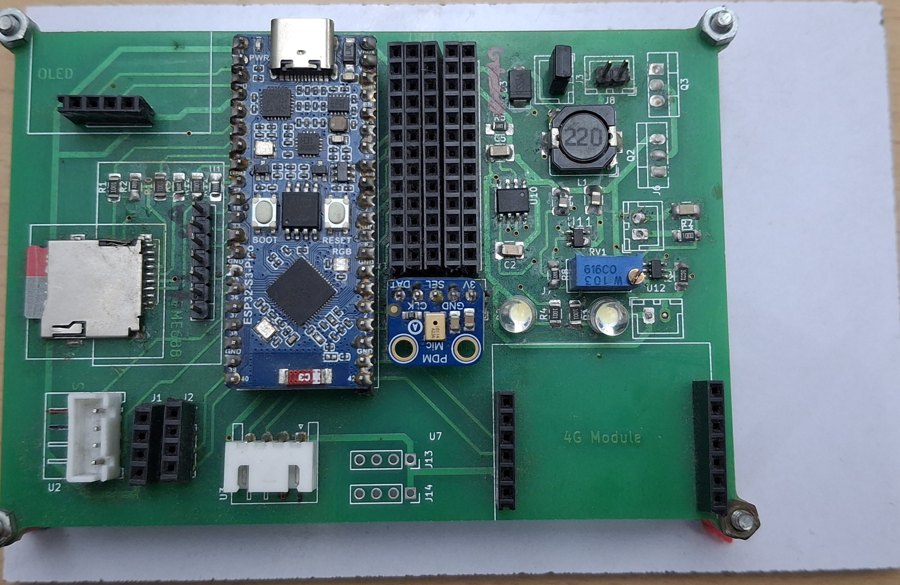

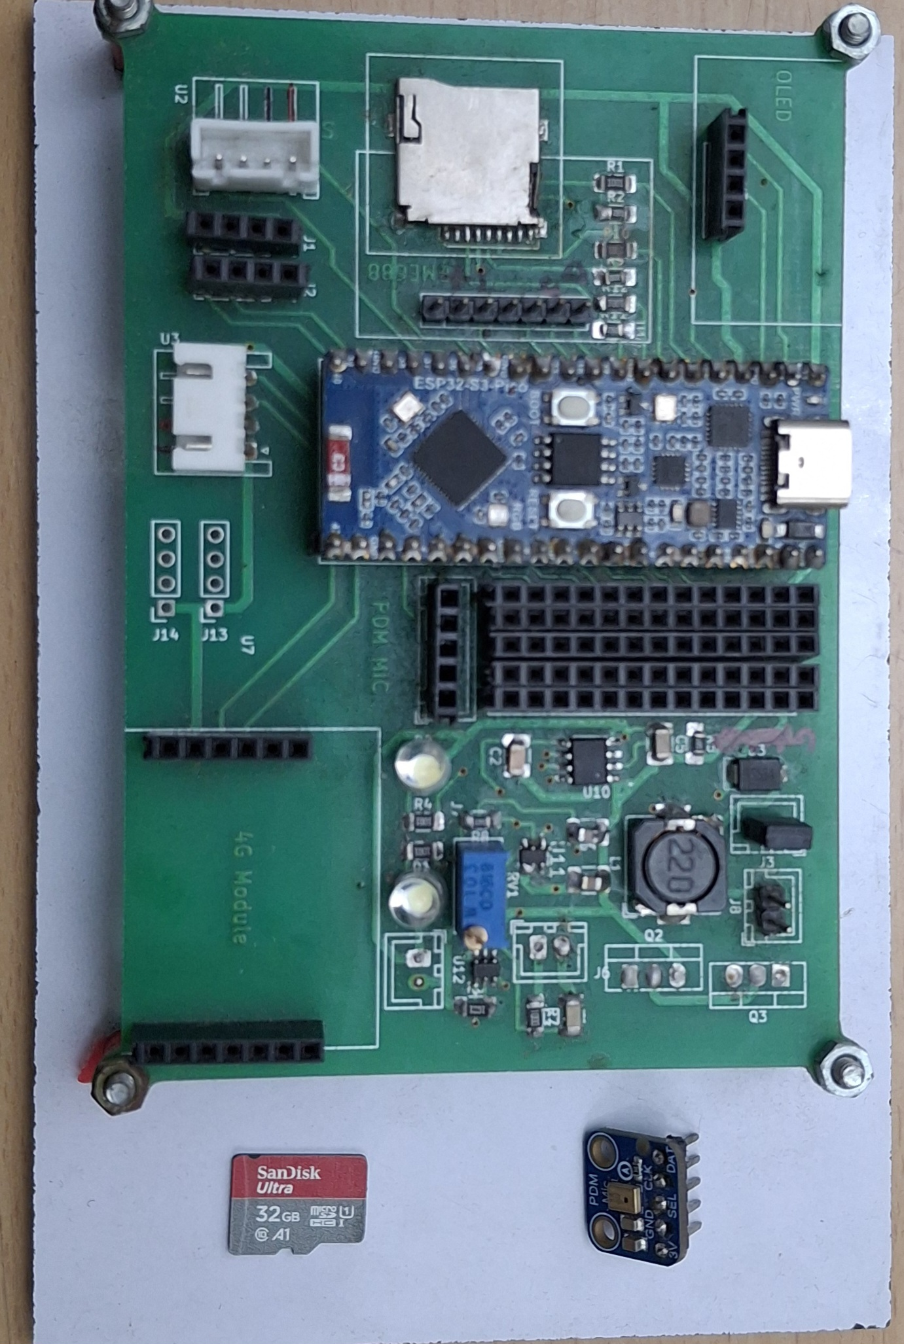

**Data Collection**

* Audio data was recorded using the PDM microphone and saved in WAV format onto the SD card.
* Each class was recorded in diverse environments to improve generalization.
* **Data Augmentation** techniques such as pitch shifting, time stretching, and background noise addition were applied to enhance dataset size and robustness.

**Sound Classes**

The system was trained to classify audio into six categories:

1. Alarm
2. Bell
3. Crying Baby
4. Dog
5. Rain
6. Rooster

**Improving Audio Quality**

* **Automatic Gain Control (AGC)** was applied to normalize audio amplitude.
* Filtering and denoising techniques were used to suppress background noise.
* Consistent audio levels across all recordings ensured better model accuracy.

**Feature Extraction**

**Technique: Mel-Frequency Cepstral Coefficients (MFCC)**

* Audio signals are converted to the frequency domain using **Fast Fourier Transform (FFT)**.
* FFT output is passed through a set of **Mel filters** based on human auditory perception.
* The result is a **Mel-spectrogram**, a visual representation of spectral energy in time.
* The spectrogram is converted to grayscale images (0-255) for input to the neural network.

**MFCC Characteristics:**

* More filters are applied in lower frequency ranges, which align with human hearing sensitivity.
* This representation emphasizes perceptually important frequencies.

**Model Training**

**Initial Model Training on PC**

The extracted MFCC features were used to train multiple model architectures:

| **Model** | **Training Accuracy** | **Testing Accuracy** |
| --- | --- | --- |
| MFCC-CNN | 95.12% | 86.41% |
| LSTM | 36.12% | 34.96% |
| CNN | 15.04% | 13.90% |
| RNN | 18.74% | 17.23% |

**Model Optimization**

* Original Model Size: **401 KB**
* Post Quantization (for ESP32-S3): **65.1 KB**
* The MFCC-CNN model was selected for deployment due to its high accuracy and compact size.

**ESP32-S3 Deployment**

* The quantized MFCC-CNN model was deployed on the ESP32-S3 using TensorFlow Lite Micro.
* The ESP32-S3 performs real-time inference on audio signals.
* The model classifies sound every few milliseconds and updates predictions dynamically.

**Web Dashboard Development**

* A local **web server** is hosted on the ESP32-S3.
* The dashboard displays the **current classified sound** along with the **timestamp**.
* The interface is minimal and lightweight, optimized for low memory usage.

**Features:**

* Live update of sound class
* Display of historical classification results (within memory limits)
* Wi-Fi-based access on local network

**Real-Time Testing**

* The end-to-end pipeline was tested in real-world environments.
* Sound detection was validated across different ambient conditions.
* The system showed high responsiveness and maintained classification accuracy in noisy settings.

**Challenges**

**Noise Handling**

Environmental noise led to some misclassifications, especially in overlapping audio scenarios.

**Memory Constraints**

The ESP32-S3 has limited RAM and flash memory, requiring aggressive model quantization and code optimization.

**Future Scope**

* Expand the number of sound classes (e.g., sirens, glass breaking, clapping).
* Add cloud integration for remote logging and analytics.
* Implement OTA (Over-the-Air) updates for improved scalability and maintainability.
* Explore more efficient model architectures such as MobileNet or TinyML variants.

**Conclusion**

This project successfully demonstrates a compact, efficient, and practical implementation of sound classification on embedded hardware. The use of MFCC features and a lightweight CNN model allowed real-time audio event detection using ESP32-S3. This solution holds strong potential for scalable deployment in various smart applications, including security, health monitoring, and home automation.

**References**

* TensorFlow Lite Micro Documentation
* ESP-IDF and Arduino ESP32 Libraries
* Audio Processing: Librosa, Python Soundfile
* MFCC and Mel-Spectrogram theory papers and tutorials